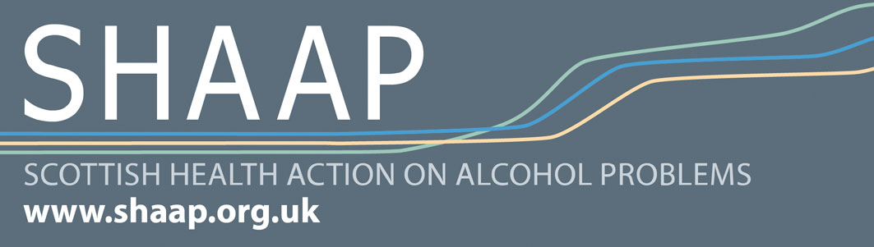
SHAAP was set up in 2006 by the Scottish Medical Royal Colleges and Faculties, through their Scottish Intercollegiate Group (SIGA). We are governed by an Executive Committee made up of members of the Royal Colleges.
SHAAP provides a coordinated, coherent and authoritative medical and clinical voice on the need to reduce the impact of alcohol related harm on the health and wellbeing of people in Scotland and how to do this.
Our aims are:
- To raise awareness and understanding of alcohol-related health problems with health practitioners, policy makers and the public
- To evaluate current research and identify strategies to reduce alcohol-related health damage, based on the best available evidence
- To work together with key organisations in the alcohol field in Scotland, the rest of the UK and worldwide, in tackling alcohol misuse
A main focus of our current workplan is our campaign in conjunction with Alcohol Focus Scotland, the British Medical Association and UK and European colleagues to support the implementation of the Scottish Government’s Minimum Unit Pricing (MUP) policy. This is an evidence-based measure which will have a significant effect on reducing alcohol-related harms among the most harmful and drinkers.
Our workplan also covers the impact of alcohol-related harm across the life course. As part of this, we have recently published reports on Alcohol and Adolescence, Alcohol and Cancer and Public Health and Big Business.
Our ‘Alcohol Occasionals’ lunchtime seminar series, in conjunction with the Scottish Alcohol Research Network (SARN) has focussed in its first year on Young People and Alcohol. From September 2014, the theme will be Alcohol and Mental Health.
We are currently developing plans around work on Alcohol in Medical Education and Liver Disease. We are also embarking on small research projects on Alcohol Brief Interventions, LGBT people and Alcohol and Women and Alcohol.
Follow us on twitter: @shaapalcohol #MUPsaves lives

