Job Description

Section 1 – Description

Job Title: Education Assistant

Location: Royal College of Physicians of Edinburgh (RCPE), 11 Queen Street, Edinburgh

Reports to: Education Manager

Date: April 2024

Section 2 – Job Purpose

To provide administrative support for education events, which includes a range of symposia, courses, evening and international medical updates.

Section 3: Organisation Chart

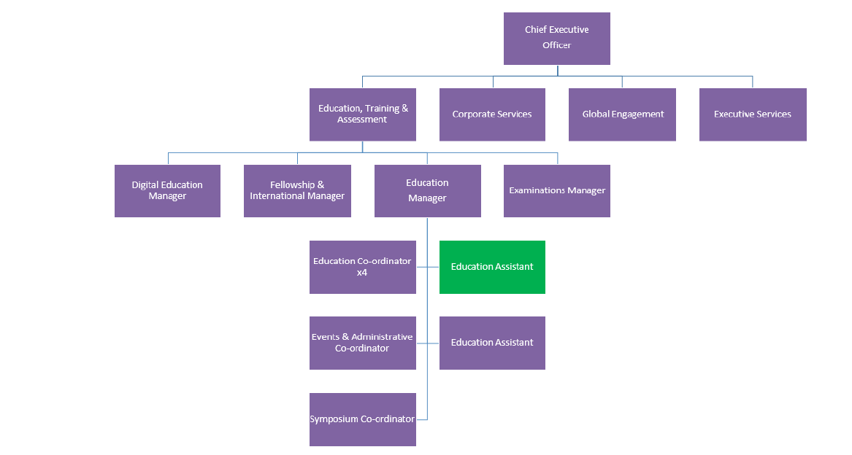

Section 4 – Dimensions

- Support approximately 17 education events per year.
- Work with other Education Assistants to process registrations for events, prepare event feedback surveys, collate feedback reports, and issue CPD certificates.
- Support Education Co-ordinators in welcoming and registering delegates at in-person/hybrid events and taking credit/debit card payments where necessary.
- Setting up and monitoring the College’s interactive Q&A and voting system (Slido) at events.
- Provide technical assistance to colleagues and delegates when using the College’s booking system.
- Monitor event live webstreams – supporting delegates and liaising with the AV and IT departments on any streaming issues.

Section 5 - Main Responsibilities and Role

- To provide administrative support, working closely with other Education Assistants, for education events, which includes a range of symposia, courses, evening and international medical updates.
- To provide webstream and Slido (interactive Q&A and voting system) support for events where needed.
- Provide practical support to Event Coordinators to assist the smooth administration of the departments and events.
- To provide administrative support to the Dean of Education.
- Supporting the Fellowships and International Manager one day a week, focussing on administration including travel requests from the International Executive and other College representatives.
- Responsibility for arranging international travel for committee members.
- To maintain and update relevant webpages.
- Create and improve on standard operating procedures for new processes and systems.
- Research and develop technological improvements to current processes and systems.
- To provide support for event programmes including preparation of delegate information, feedback, and issuing CPD certificates electronically.
- Answering phone calls and responding to emails from delegates.
- Data entry of speaker’s details into an Access database and providing data for reporting as instructed by the Education Manager and Head of Department.
- Annual archiving of files in liaison with Education Co-ordinators.
- To provide ad-hoc support to work streams as directed.

Section 6 – Planning and Organising

In discussion with the Education Manger the post-holder will be largely responsible for forward planning their own workload, starting with dates for providing support for education events in coordination with the other Education Assistants and the Education Coordinators.

Section 7 – Decision Making

- Notify Education Coordinators and other relevant staff about progress with administrative preparations for events, and raising any issues of concern that arise.
- Identify potential improvements which could be made to departmental processes.
- Responsible for day-to-day organisation of workload and determining own priorities
- To monitor and moderate delegate interaction using Slido.

Section 8 – Internal and External Relationships

Internal
Director of Education Training & Assessments
Education Manager
Fellowships and International Manager
Digital Education Manager
Education Assistants and Education Coordinators
College Staff
Fellows and Members

External
UK and International Delegates
Sponsors and Exhibitors

Section 9 – Person Specification - Knowledge, Skills and Experience Required

Essential
- Excellent attention to detail.
- Good verbal and written communication skills.
- Ability to manage potentially conflicting priorities, and remain calm under pressure.
- Well-developed IT skills including MS Office software and the ability to use video conferencing software.
- Self-starter and highly motivated.
- Excellent team player, with the confidence to share experience and knowledge with colleagues.
- Exceptional people skills with a dedication to ensure a high level of customer service.
- Positive ‘can do’ attitude and ability to accommodate change.

Desirable
- Interest in education/event support.
- Demonstrable experience of providing routine administrative support.
- Ability to identify own training needs and conduct self-directed learning and upskilling.
- Previous experience of a customer care environment.

Section 10 – Job Context and Special Features

The College is growing its learning and development portfolio and requires an individual who is highly motivated with excellent attention to detail, and can work at pace. They need to be digitally savvy and good at improving processes, whilst thriving in a customer oriented environment. The support required by the Education Co-ordinators is cyclical and will, on occasion, require the post-holder to be flexible regarding hours of work.

This job description will be updated and amended from time to time in accordance with the requirements of the job and the changing needs of the College.

