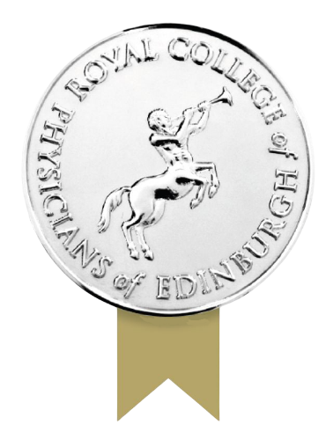

Physicians’ Collections Research Grant | 2026

The 2026 Physicians’ Collections Research Grant aims to encourage new research into, and engagement with, the College’s library and archive collections. The recipient is expected to share their research with the public through a variety of channels.

This grant is funded through the generosity of the Joyce Grainger Charitable Trust.

The grant enables the recipient to carry out research on the College’s historic collections. The recipient is expected to spend around 4 weeks at the College accessing our collections. The research and required outputs must be completed by 1 March 2027.

The grant recipient will receive:
- A grant of £3,000 towards subsistence and travel expenses.
- Study space in the College’s Reading Room at 11 Queen Street, Edinburgh.
- Research support from the College’s library and archives staff.

Applying

Eligibility

The grant is open to UK-based researchers in any discipline. Applicants must not be a current employee of the College, although Fellows and Members of the College are welcome to apply.

Selection Criteria

The selection committee will consider applications according to the following criteria:

- The role which the College’s collections will play in the research, including details of which collections or items will be utilised.
- How the research project will be original/innovative.
- The usefulness of the project to researchers and/or the wider public.
- How the project will be delivered within the available time, including specific milestone dates.
- What the outcomes of the project will be.
- How details of the research project and its findings will be shared with researchers and/or the wider public.

The grant can only be awarded to an individual once.

The Library and Archives

The College library was established in 1682 when Sir Robert Sibbald, donated “three shelfes full of books to the Colledge of Physitians". It was the first library in Scotland specifically intended for the study of medicine.

The library contains over 70,000 books, including a copy of the first edition of the first book printed on medicine - the De Medicina of Celsus, published in 1478 - and almost 1500 journals, some of which are particularly rare. The archives contain over 400 externally deposited manuscript collections concerning eminent scientists such as Joseph Black and William Cullen.

You can find out more about the collections and access the College’s online library and archives catalogues at https://www.rcpe.ac.uk/heritage/library-archive

Core subject and collection strengths

- History of public health and charitable medicine
- 18th century Scottish medicine
- History of medical education, particularly in Edinburgh
- Social and cultural history
- History of mental illness and psychiatry
- Medical journals
- Materia medica
- Royal College of Physicians of Edinburgh, including the work of Fellows and Members
- History of military and naval medicine
- Historical patient case notes
- Natural history, including botany

Outcomes

The grant recipient will:

- Carry out in-person research in the College's reading room using the College’s collections.
- Provide a brief end of project report.
- Provide a related blog post.
- Deliver at least one additional output as described in the awardee’s research proposal. Examples of such an output would include, but are not limited to, a podcast, conference paper, public display or online exhibition.
- Acknowledge the grant in any resulting publications.

Submission Information

The closing date for applications is 1 April 2026.

Applicants should email the following documents in either PDF or Word format to library@rcpe.ac.uk, with the subject line “Physicians’ Collections Research Grant”:
- A completed application form.
- A research proposal, not more than 1000 words in length. This should include information regarding each of the elements of the Selection Criteria detailed above.
- A curriculum vitae, not exceeding two sides of A4.
Physicians’  Collections  Research Grant | 2026 | 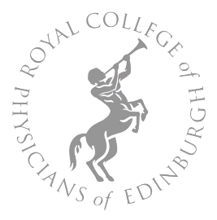

Application Form
This application form should be fully completed and submitted with a PDF or Word version of the research proposal and curriculum vitae to the email: library@rcpe.ac.uk by 1 April 2026.

Contact Information

First Name |  |  | Surname
Institution (if applicable)

Telephone number(s)

Email address

Abstract & CV

The research proposal should be submitted with this form in either PDF or Word format and must not exceed 1000 words in length. Your CV should be submitted with this form in either PDF or Word format and must not exceed two sides of A4.

Yes – my proposal is attached in PDF/Word format

Yes – my CV is attached in PDF/Word format

Statement

By completing this application form, I certify that the proposal relates to original research.

Signature

Date

