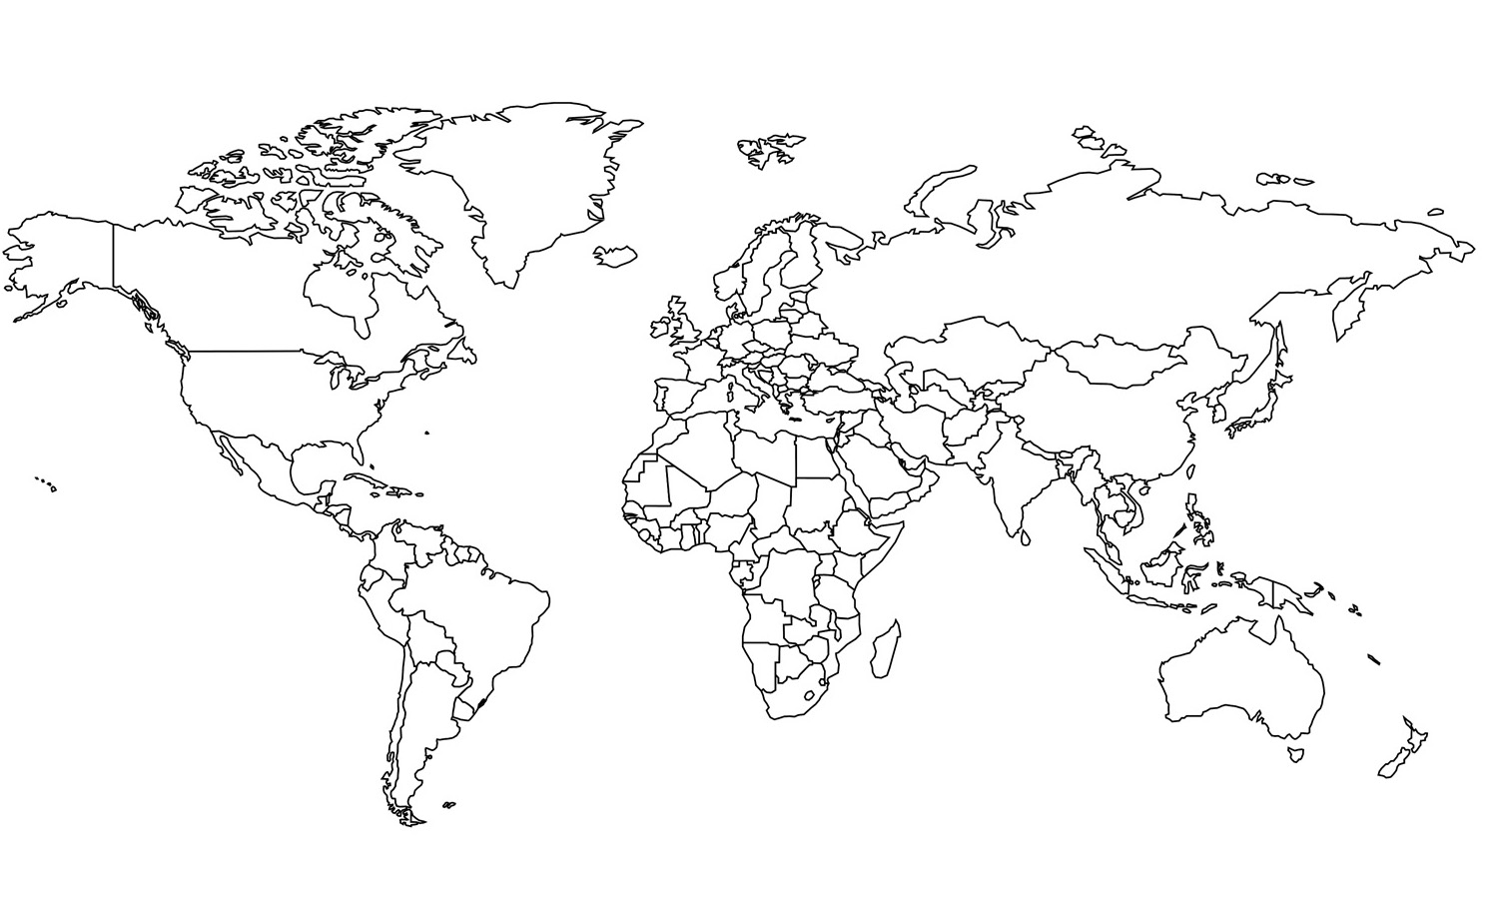

*Ingredients and Objects found in* ***LONDON***

1. *UCAL BRONCHIAL LOZENGE TIN*

*Ingredient found in* ***SPAIN***

1. *SEVILLE ORANGES*

2. *CANTHARIDE*

3. *ROSEMARY*

*Ingredient found in* ***MOROCCO***

1. *CARAWAY SEED*

*Ingredients found in* ***GREECE***

1. *ELLICAMPANE ROOT*

2. *SAFFRON*

*Ingredient found in* ***INDONESIA***

1. *NUTMEG*

*Ingredient found in* ***CHINA***

1. *STAR ANISE*

*Ingredients found in* ***TURKEY***

1. *LIQUORICE ROOT*

2. *RAISINS*

*Ingredient found in* ***CARIBBEAN ISLANDS***

1. *GUAIACUM*

*Ingredients and Objects found in* ***FRANCE***

1. *CADUM OINTMENT*

ANSWER KEY

*Ingredients and Objects found in* ***SCOTLAND***

1. *SHEEP’S PURLES*

2. *HONEY*

3. *WHEAT*

4. *SCURVY GRASS*

5. *ROSE*

6. *BEESWAX*

7. *GREGORY’S POWDER*

*Ingredients found in* ***INDIA***

1. *SENNA*

2. *SUGAR*

3. *CASSIA*

4. *MUSTARD*

5. *BALSAM*