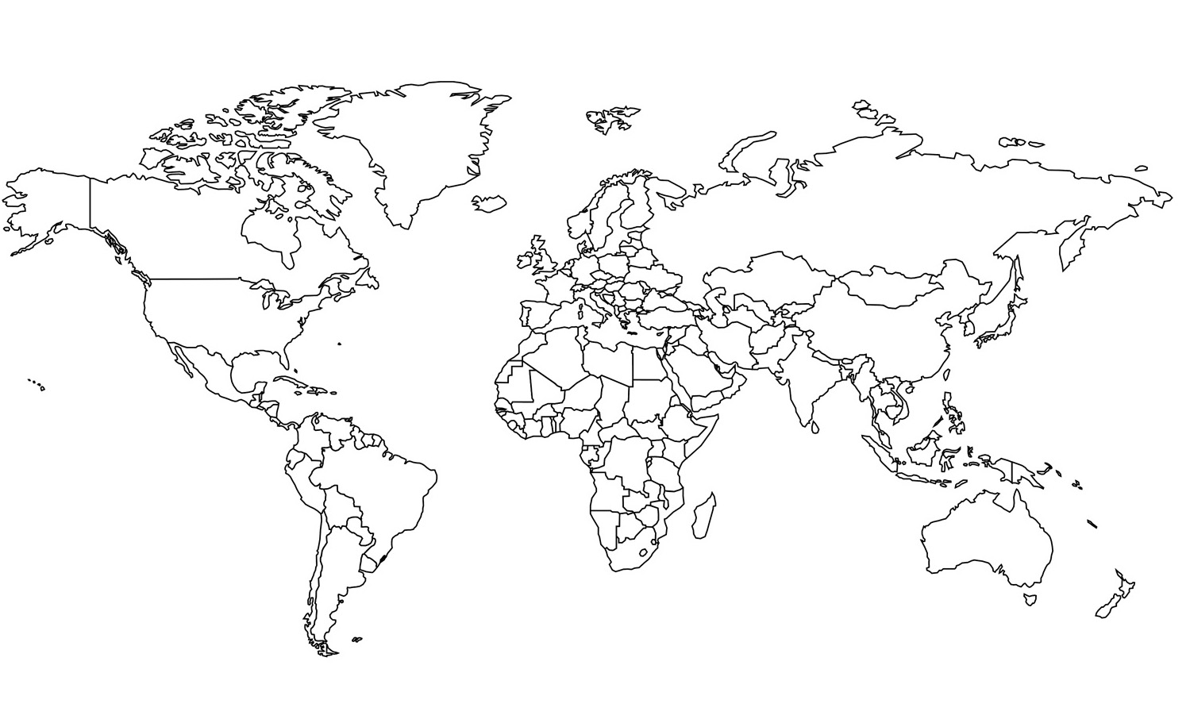

Name: __________________________________

*Ingredients and Objects found in* ***LONDON***

1. *__________________________*

*Ingredient found in* ***SPAIN***

1. *__________________________*

2. __________________________

3. __________________________

*Ingredient found in* ***MOROCCO***

1. *__________________________*

*Ingredients found in* ***GREECE***

1. *_________________________* 2. _________________________

*Ingredient found in* ***INDONESIA***

1. *__________________________*

*Ingredient found in* ***CHINA***

1. __________________________

*Ingredients found in* ***TURKEY***

1. *__________________________*

2. *__________________________*

*Ingredient found in* ***CARIBBEAN ISLANDS***

1. *__________________________*

*Ingredients and Objects found in* ***FRANCE***

1. __________________________

*Ingredients and Objects found in* ***SCOTLAND***

1. *__________________________*

2. *__________________________*

3. *__________________________*

4. *__________________________*

5. *__________________________*

6. *__________________________*

7. *__________________________*

*Ingredients found in* ***INDIA***

1. *__________________________*

2. *__________________________*

3. *__________________________*

4. *__________________________*

5. *__________________________*