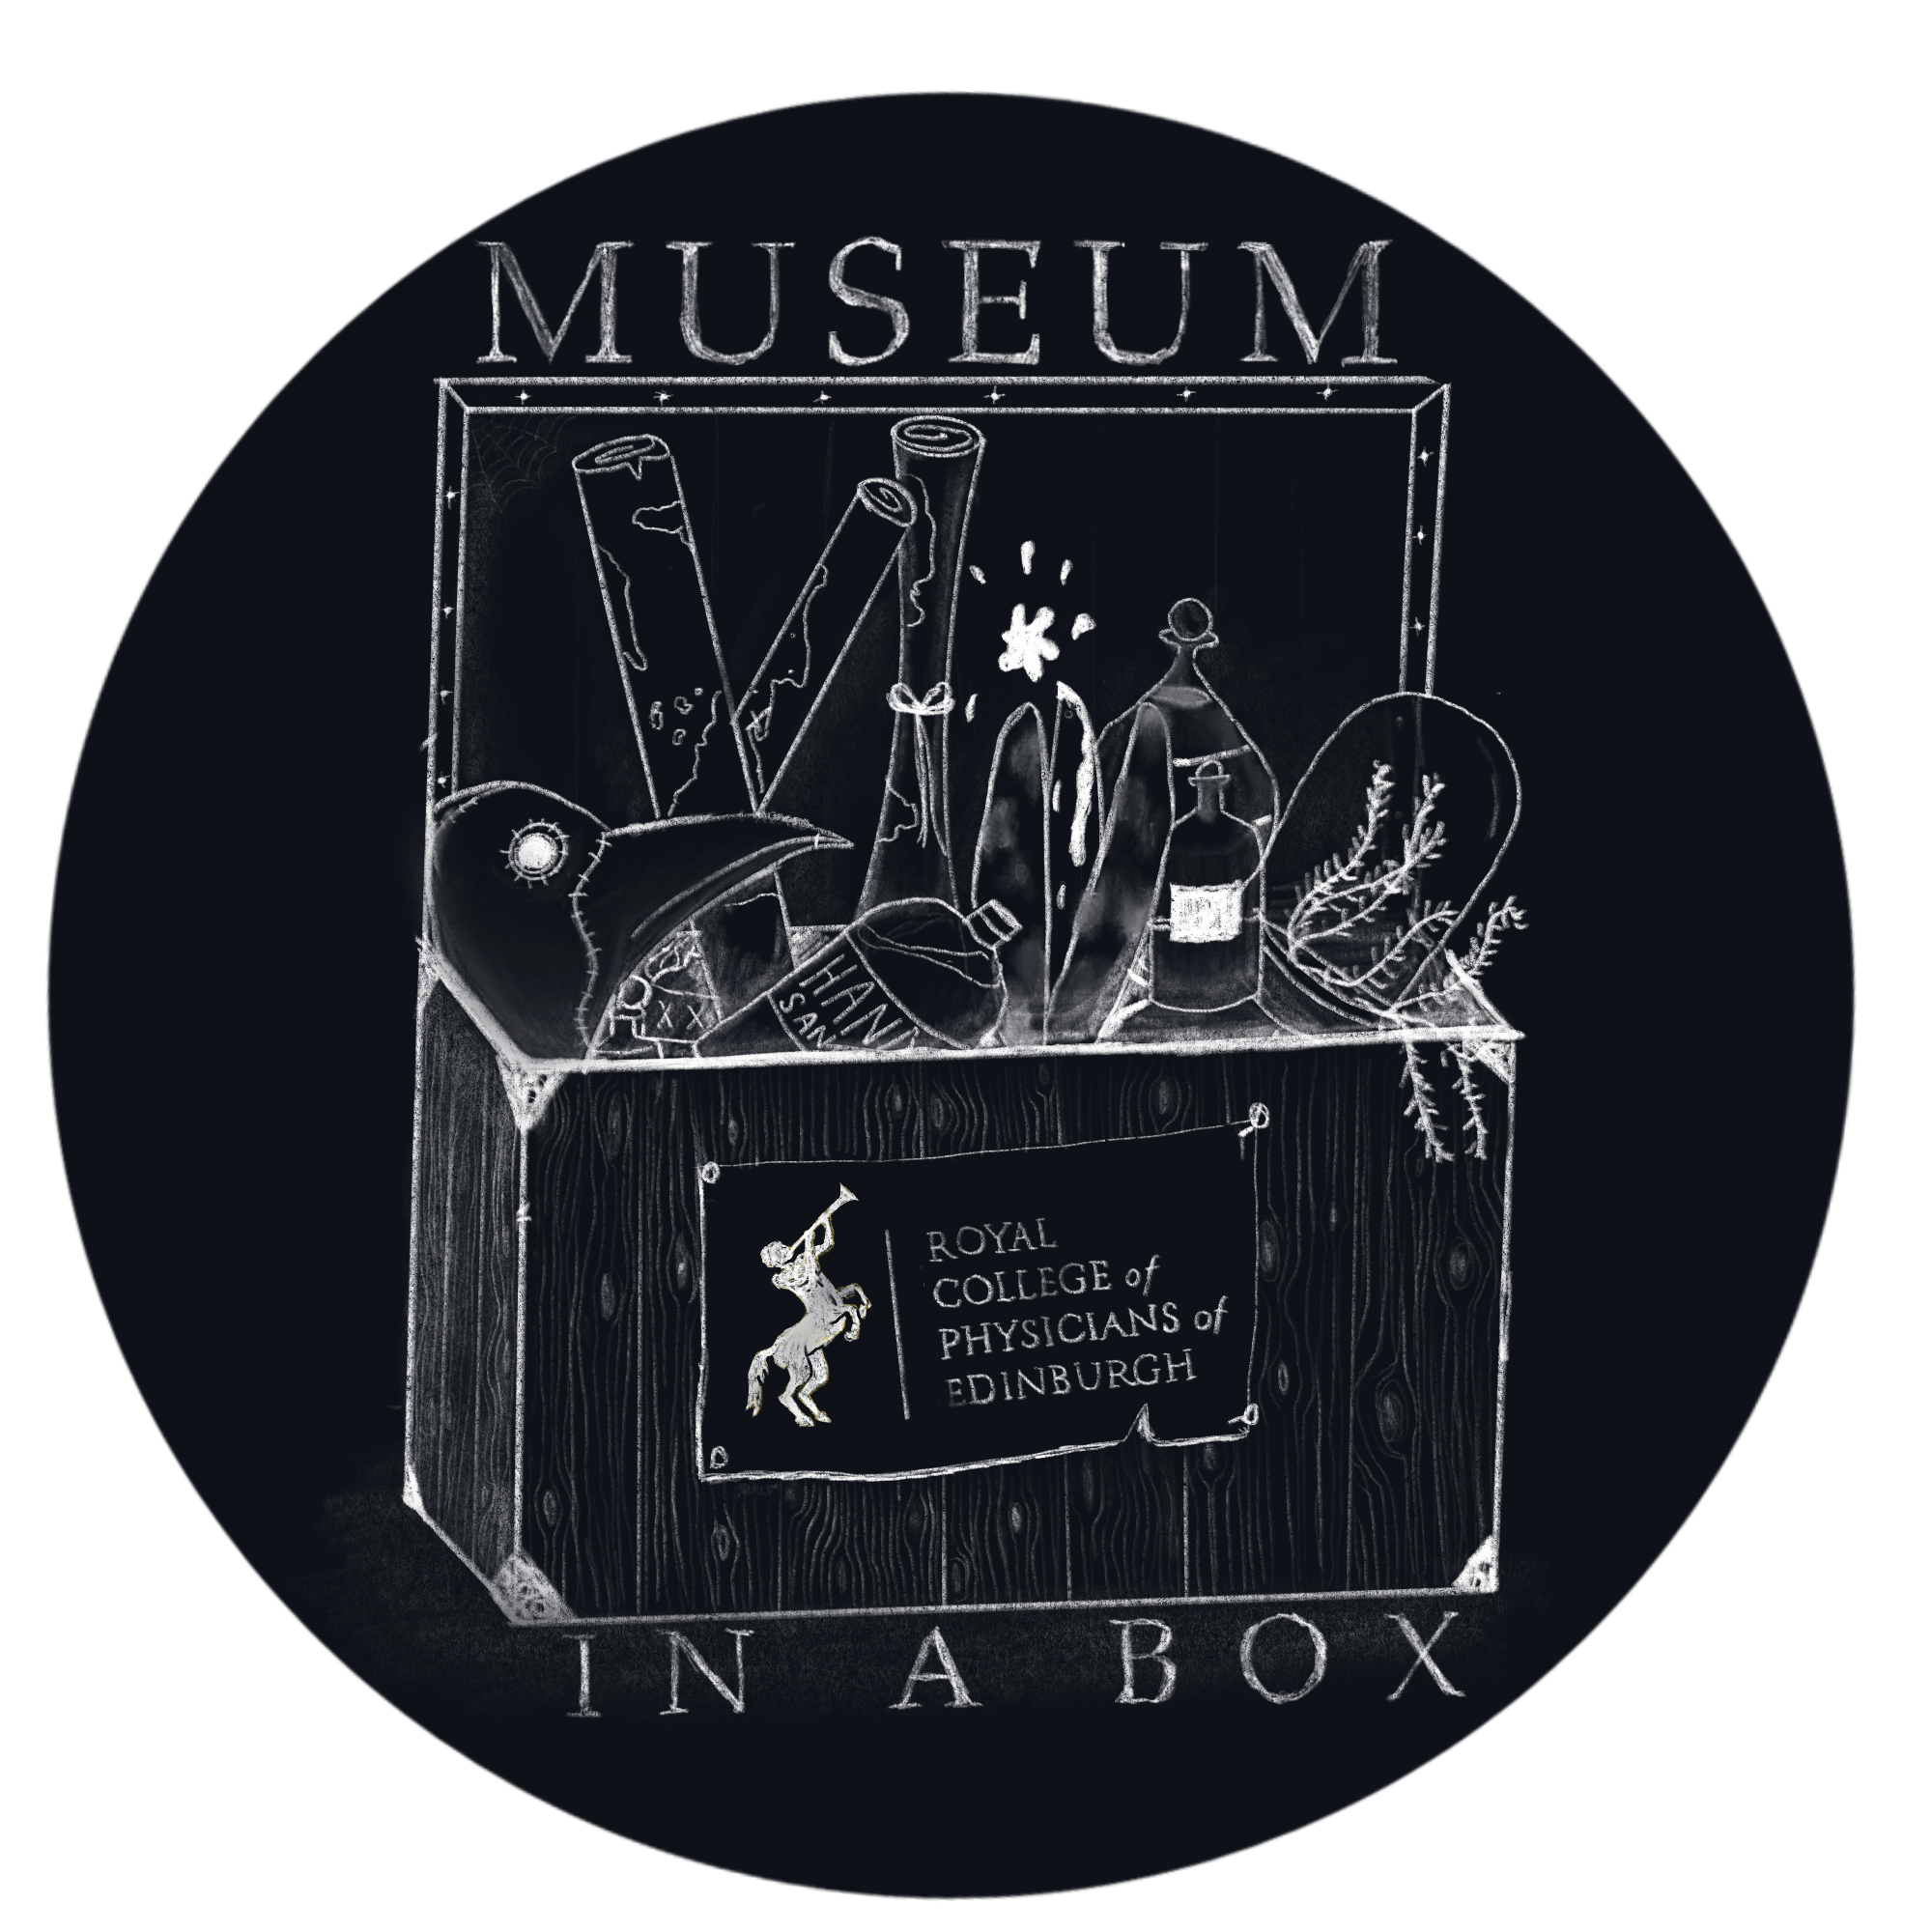
Name _______________________________

Herbarium or Objects ___________________________

What ingredients or objects do you recognize?

What ingredients or objects you do not recognize?

Some of these ingredients and objects are curious, why do you think some ingredients and objects were added or used?

In a moment, you will make an advertisement poster for your herbarium or objects. Use the following space to create a rough draft of the advertisement.
The poster should:
- Have the name of the remedy
- Be colourful and attractive
- Contain drawings of what would be in the recipe for the remedy
- Describe what it can cure
- There are sometimes very unsavory items in the recipe, choose whether to feature the ingredient or hide it

Here is a sample of what you will be given to complete your advertisement

