Name: ______________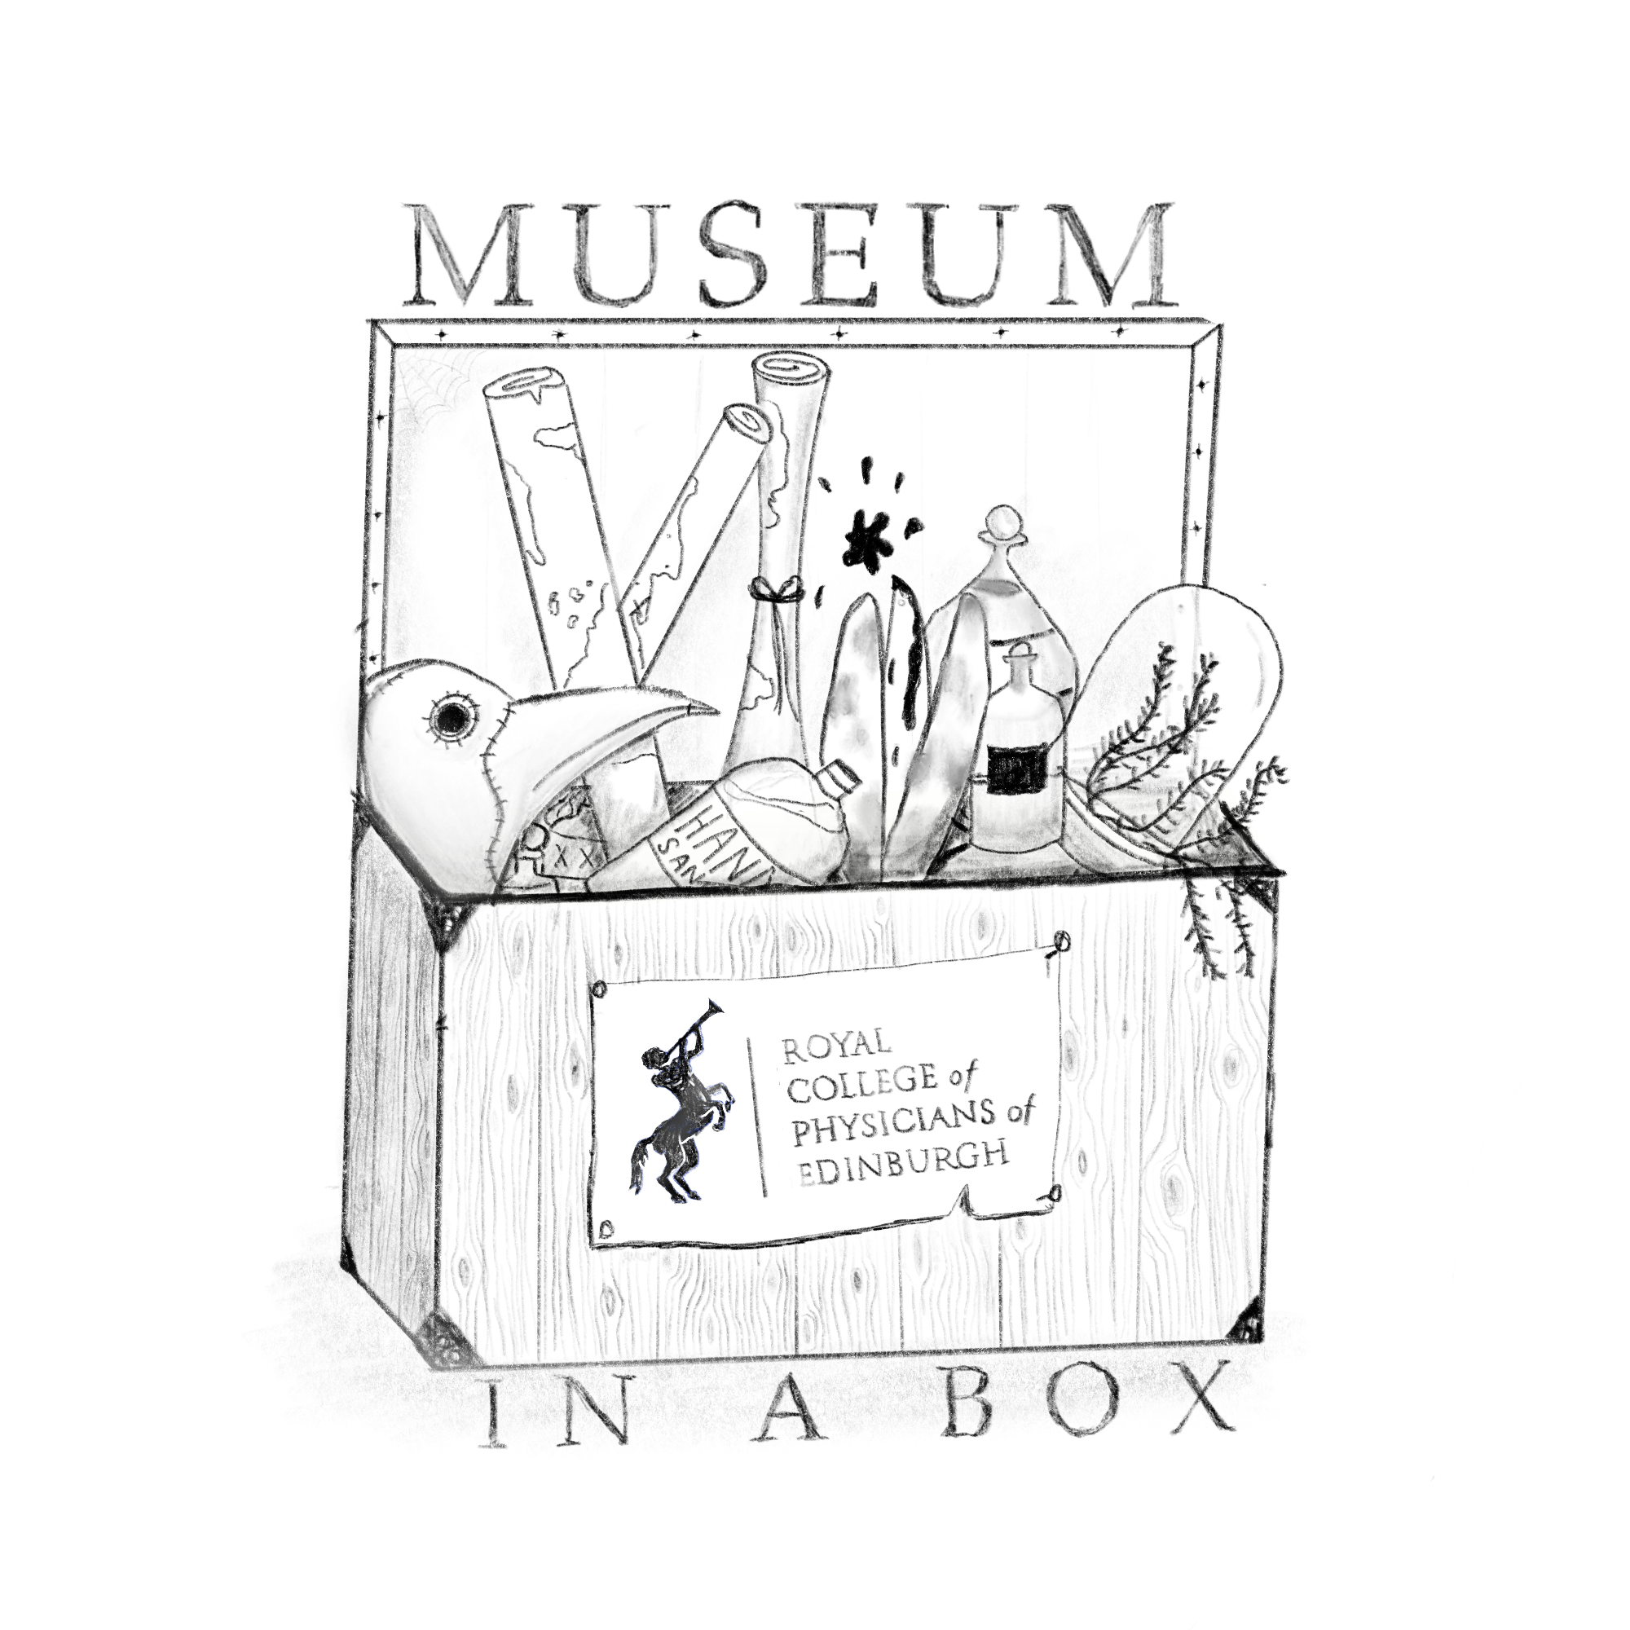_______________

|  |  |
| --- | --- |
| **What is the object/archive called?** | **Why do you think this object/archive would be useful to you?** |
|  |  |
|  |  |
|  |  |
|  |  |
|  |  |
|  |  |
|  |  |
|  |  |
|  |  |
|  |  |
|  |  |
|  |  |
|  |  |
|  |  |
|  |  |

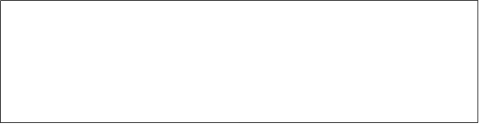

*LADY CHARTERIS OF KINFAUNS CASTLE*

*PHYSICIAN IN EDINBURGH, SCOTLAND*

*A QUACK*

*APOTHECARY THOMAS TRAQUAIR*

**I AM LOOKING AT THE OBJECTS AND ARCHIVES AS (CIRCLE ONE)**

**Be prepared to answer questions from your teacher! Use these objects to justify your answer.**

**Name the object/archive that you believe you would use and explain how/why you think it would be useful.**