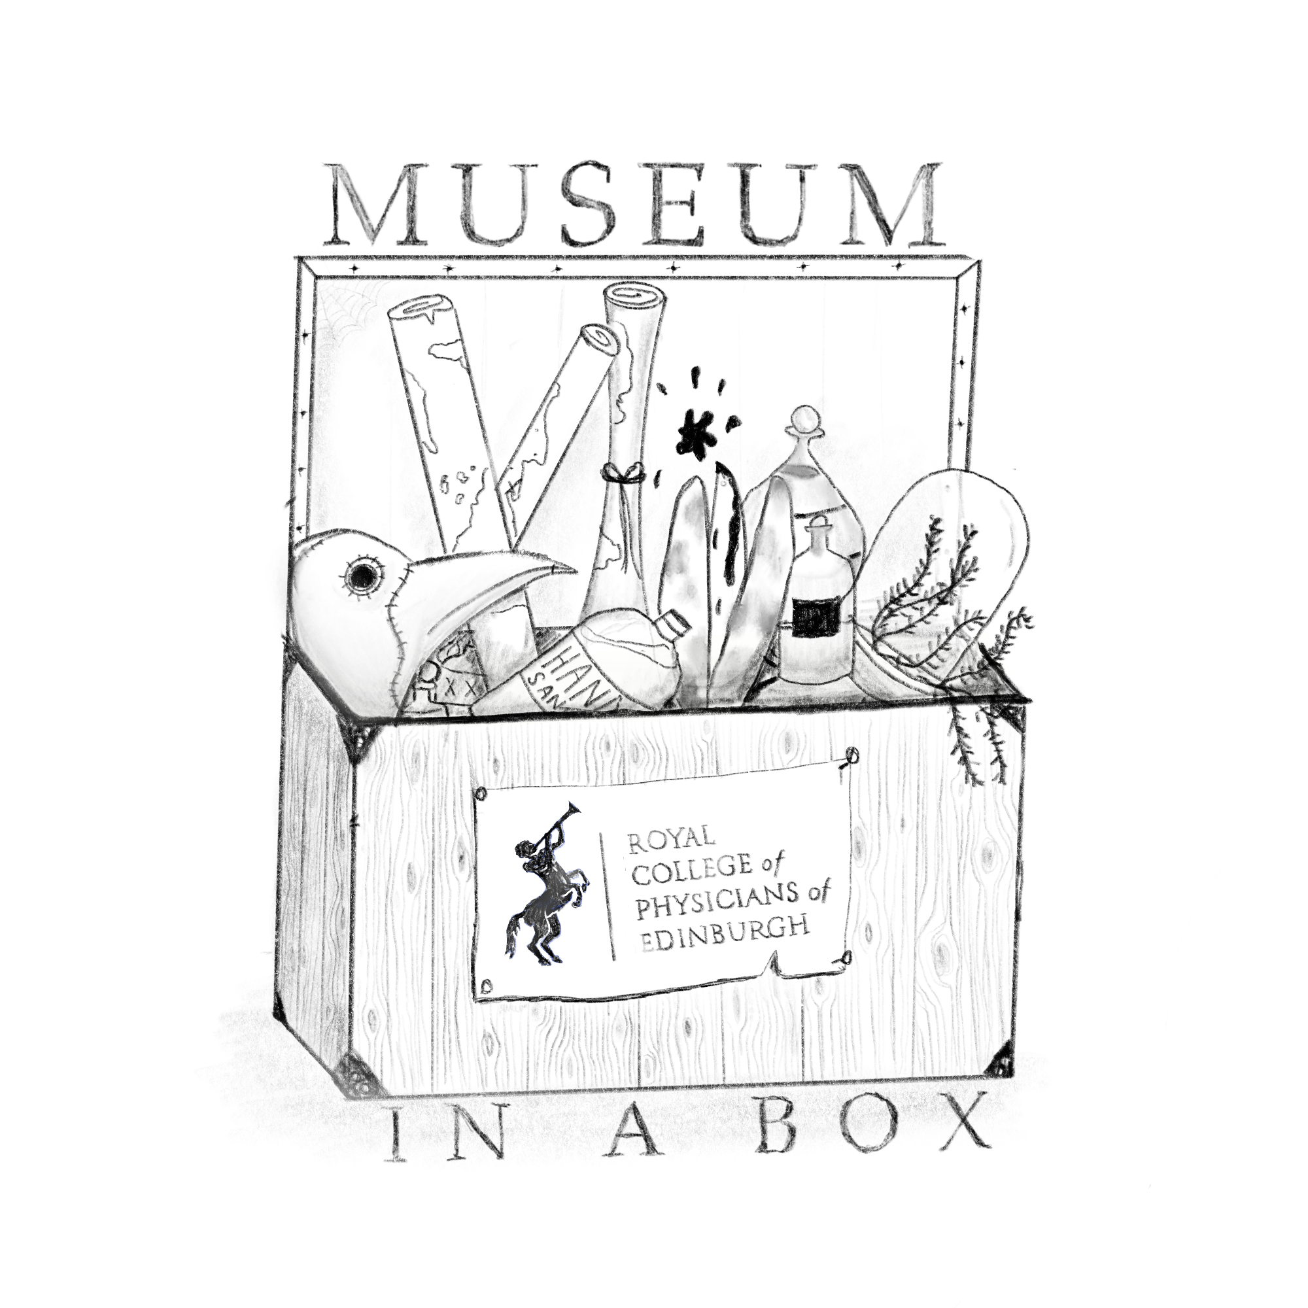
NAME: _____________________

INSTRUCTIONS: Find the objects listed below and determine:

- Whether or not the objects were the result of scientific discovery
- If the object is still in use today
- If the object was the product of a doctor’s experimentation

Carbolic Acid Catgut  1.  2.  3.  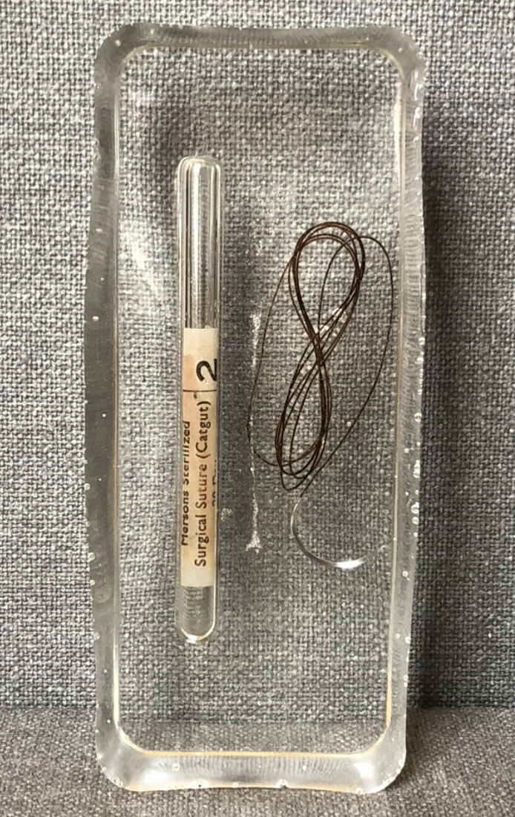 | Goop Carnelian Crystal Advertisement  1.  2.  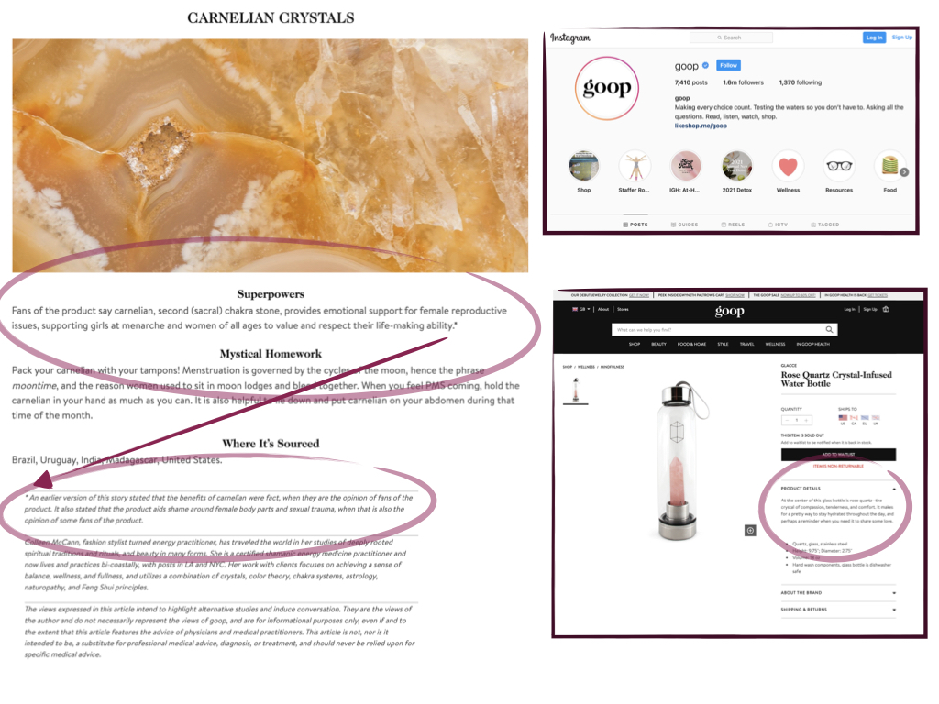  3. | Phrenology Bust  1.  2.  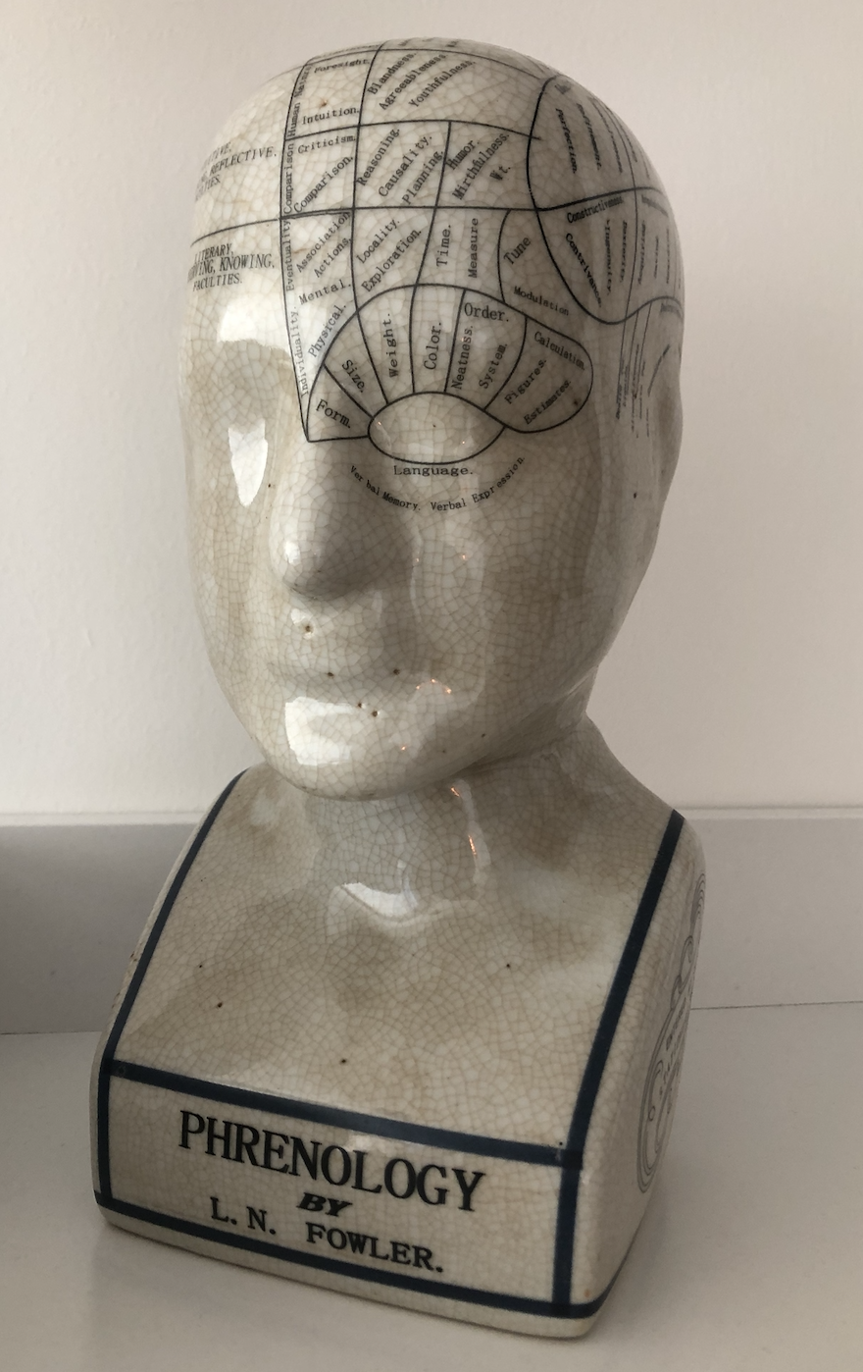  3. | X-Rays from J.W. Gifford  1.  2.  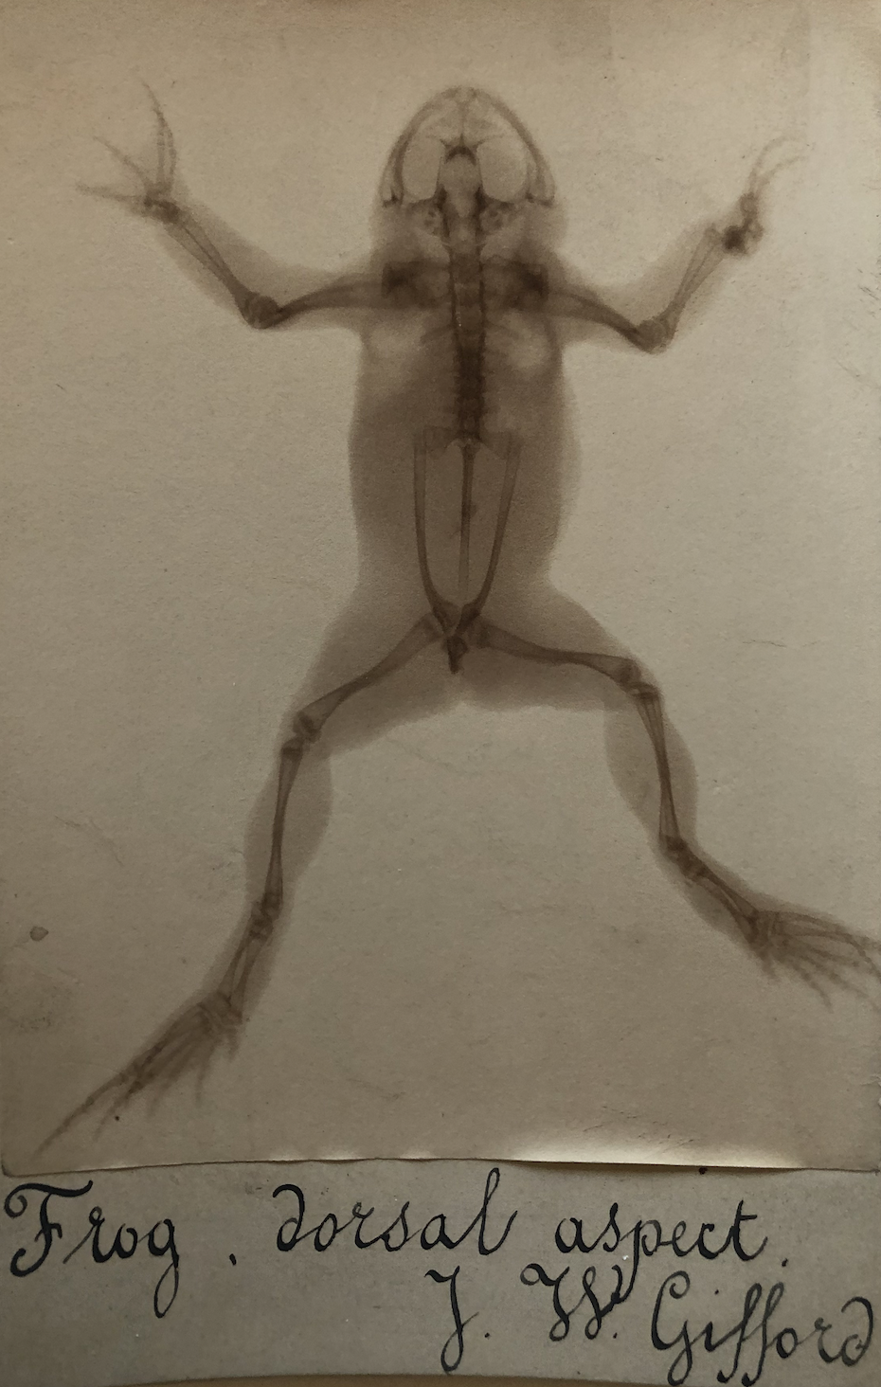  3.
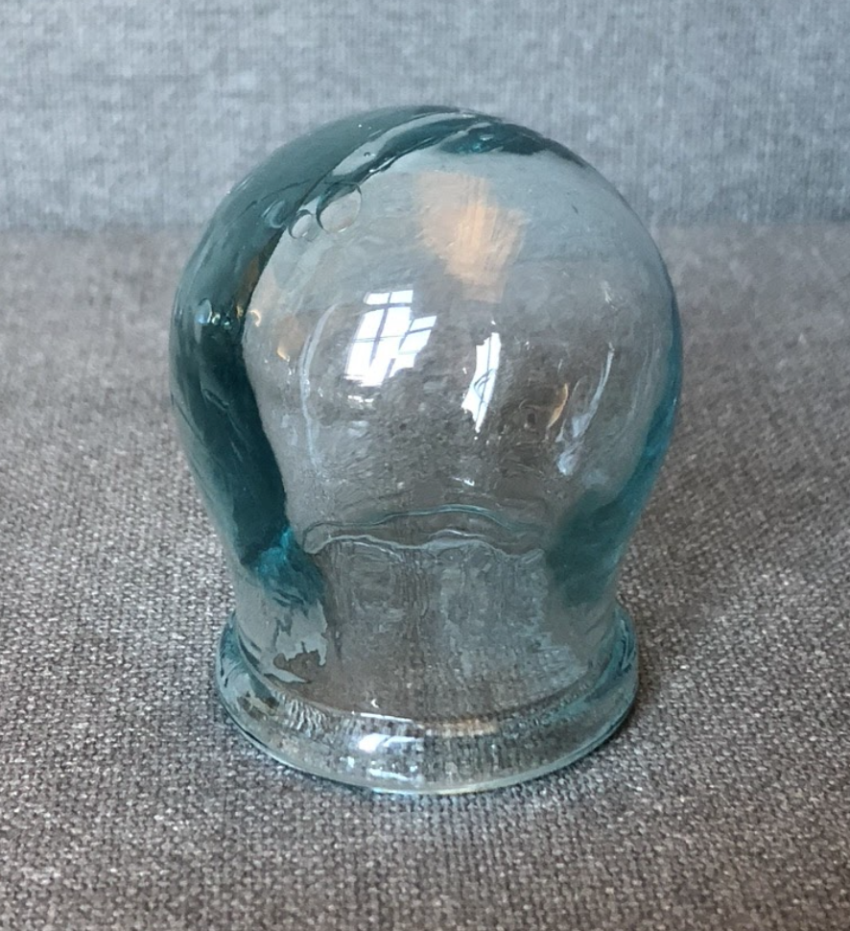
Flat Tummy Lollipop Advertisement  1.  2.  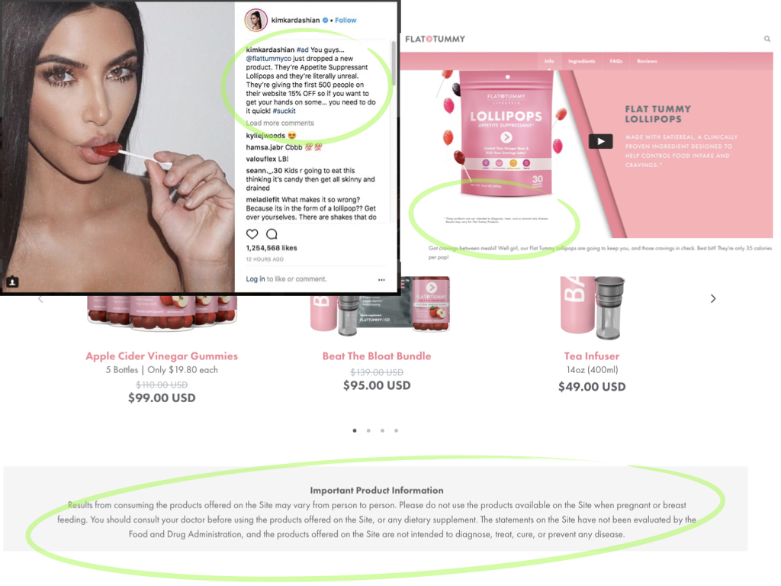  3. | Glass Cupping Cup  1.  2.  3. | Bleeding Bowl  1.  2.  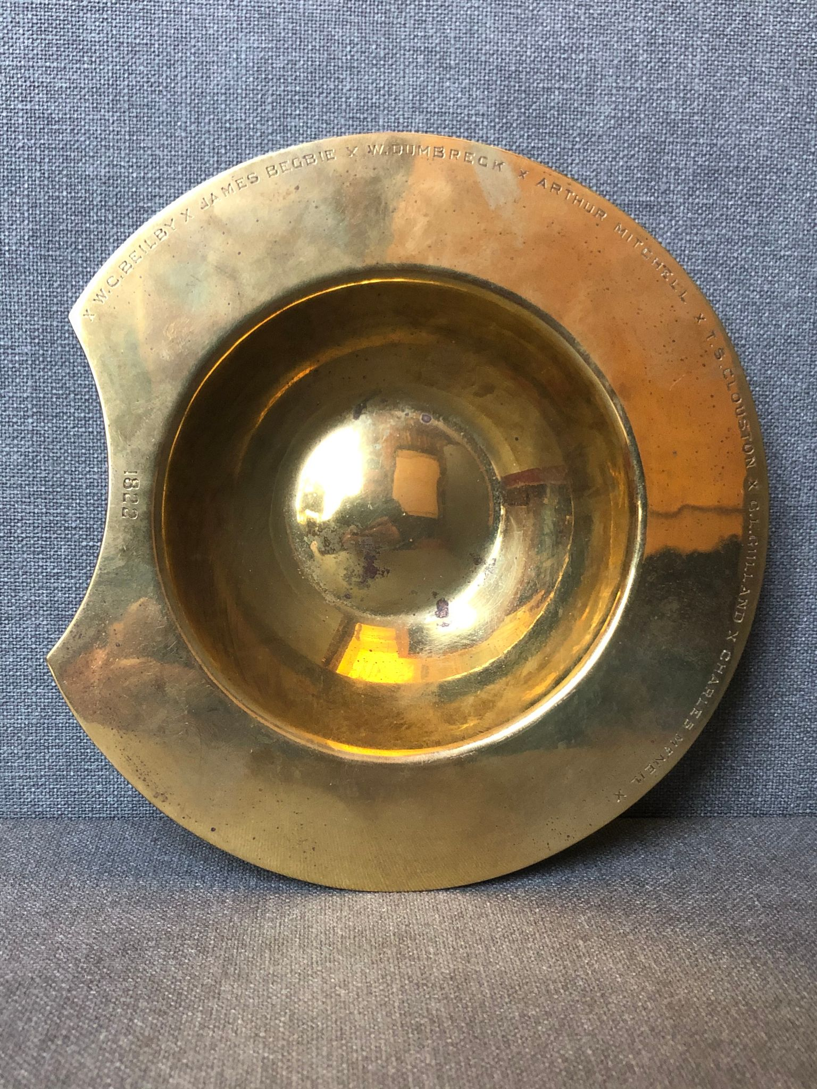  3. | Cinnabar Mineral  1.  2.  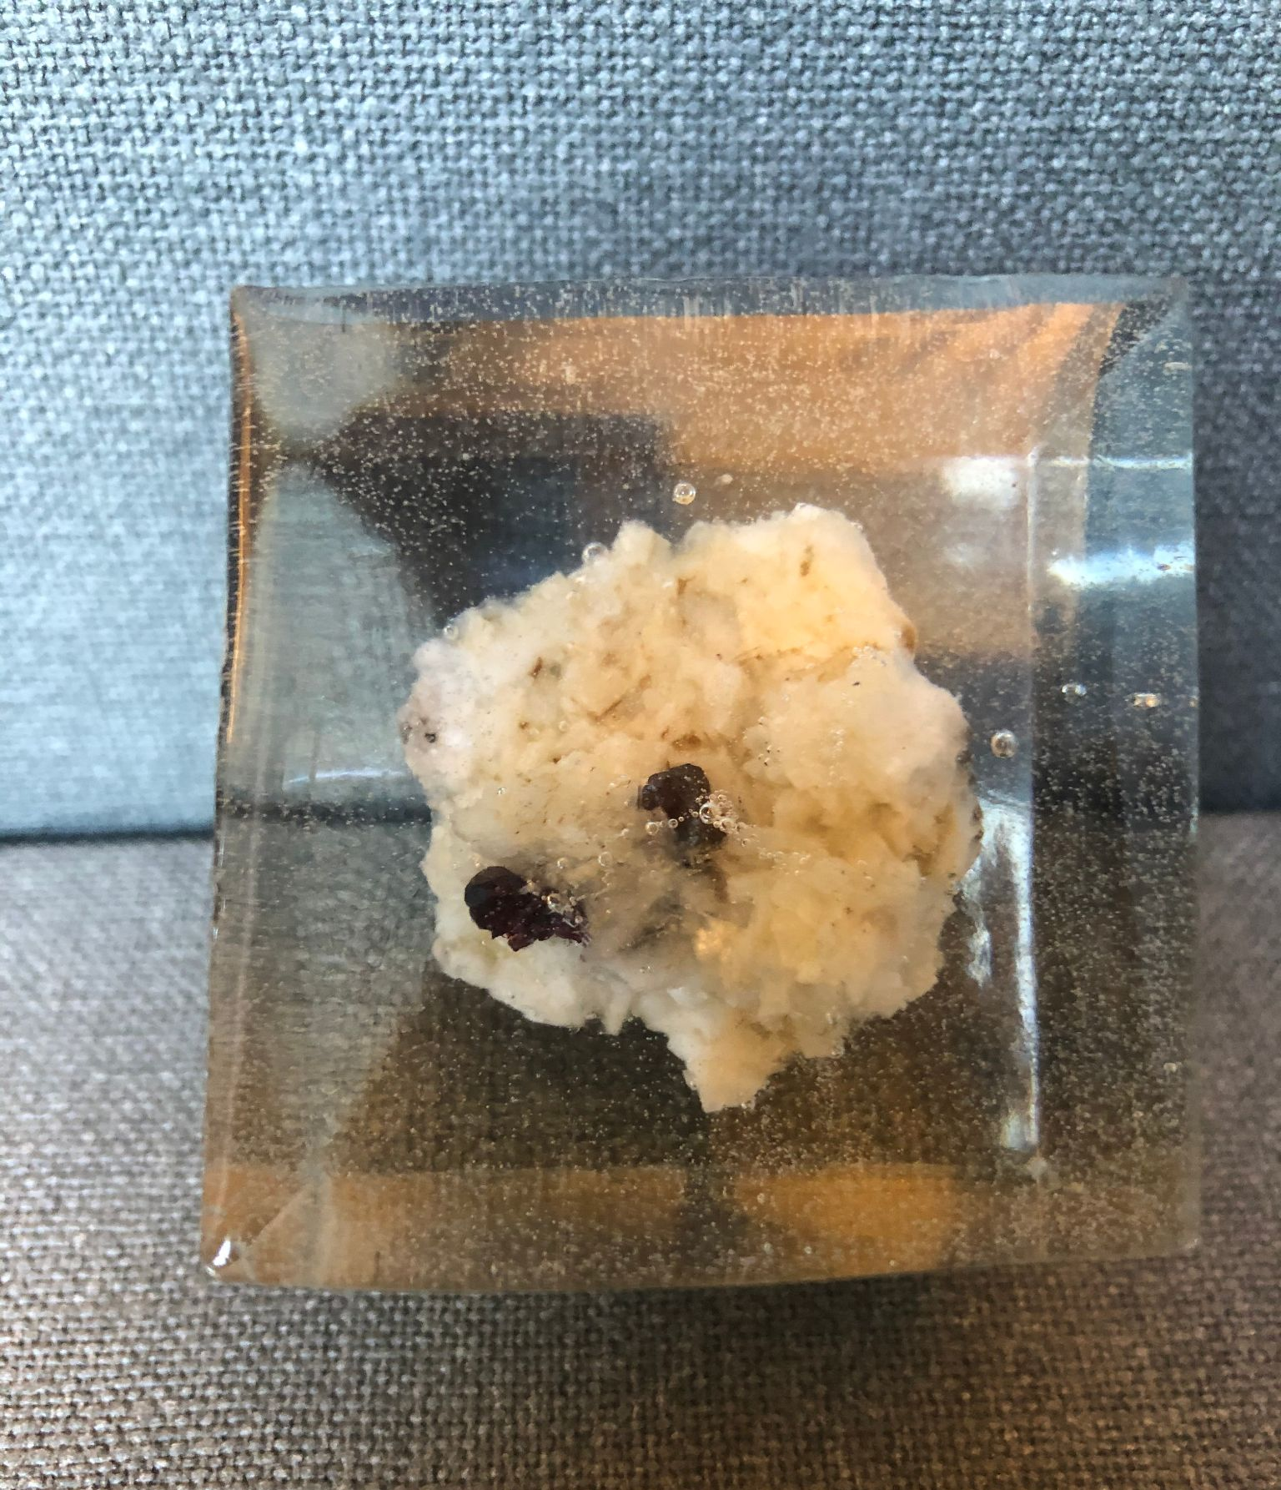  3.

