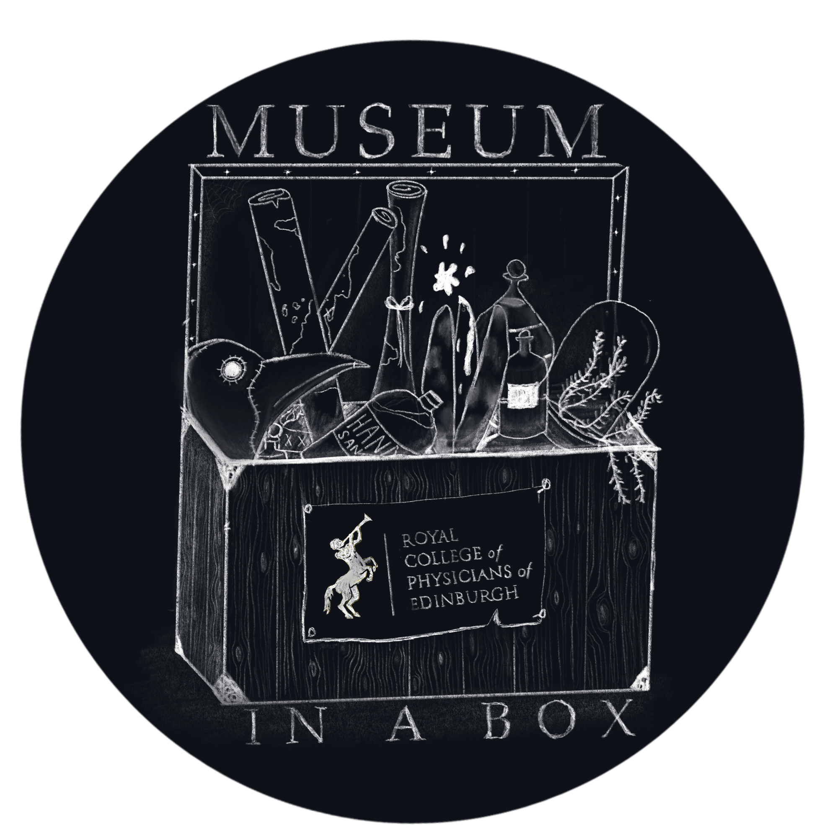
Introduction to the Box
There are 4 infectious diseases to explore. You have 5 minutes to study the objects for each disease to try and work out what the objects are and what infectious disease they are related to. Likely, you’ll get the name of the disease pretty easily. The real work will be for you to figure out how the objects relate to the infectious disease. If you are not sure what an object is, or what it does, then make an educated guess.

Disease represented in Station A
What is the object? | What does it do?

I BELIEVE THE DISEASE REPRESENTED IN STATION A IS ______________________

Disease represented in Station B
What is the object? | What does it do?

I BELIEVE THE DISEASE REPRESENTED IN STATION B IS ______________________

Disease represented in Station C
What is the object? | What does it do?

I BELIEVE THE DISEASE REPRESENTED IN STATION C IS ______________________

Disease represented in Station D
What is the object? | What does it do?

I BELIEVE THE DISEASE REPRESENTED IN STATION D IS ______________________

